**COMP3010 CW2**

Contents

Introduction: 2

SOC Roles and Incident Handling Reflection: 2

Installation and Data Preparation: 2

Splunk Installation: 2

BOTSv3 Dataset Preparation: 11

Guided Questions: 12

Question 1: 12

Question 2: 12

Question 3: 13

Question 4: 14

Question 5: 15

Question 6: 15

Question 7: 16

Question 8: 17

Conclusions: 18

References: 18

Things to Note:

* Include screenshots of bars and charts while doing the analysis in the report
* Record video showing how the installation worked – either mention that it was already done therefore just talking through it without running commands, or set up a new VM and re-run through the download of the dataset and analysis etc.
* Change VM background to name or something unique to prove that the recording is mine
* Place search terms on different lines -> Start each line (aside from the first) with |

# Introduction:

# SOC Roles and Incident Handling Reflection:

# Installation and Data Preparation:

This section will explain how Splunk was installed within an Ubuntu Linux virtual machine, as well as how the BOTSv3 dataset was loaded. As I performed the installation before taking screenshots for this section, the screenshots display later timestamps compared to those for the guided questions. To effectively demonstrate the installation of Splunk, I reinstalled it on the same virtual machine which ensured the configuration of the machine remained the same throughout this report.

## Splunk Installation:

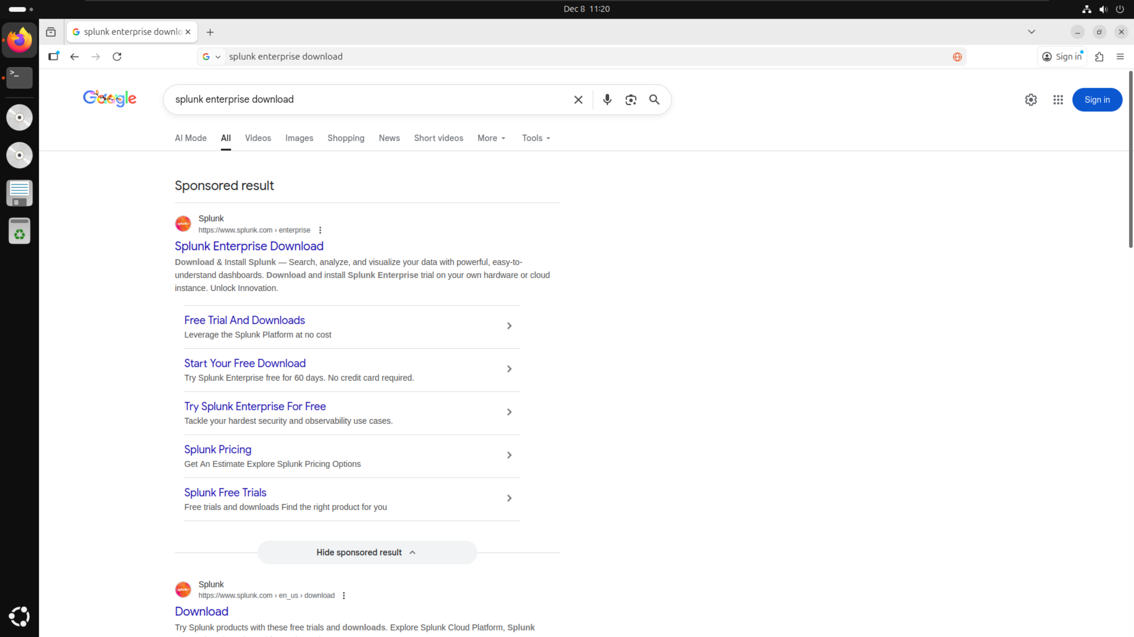

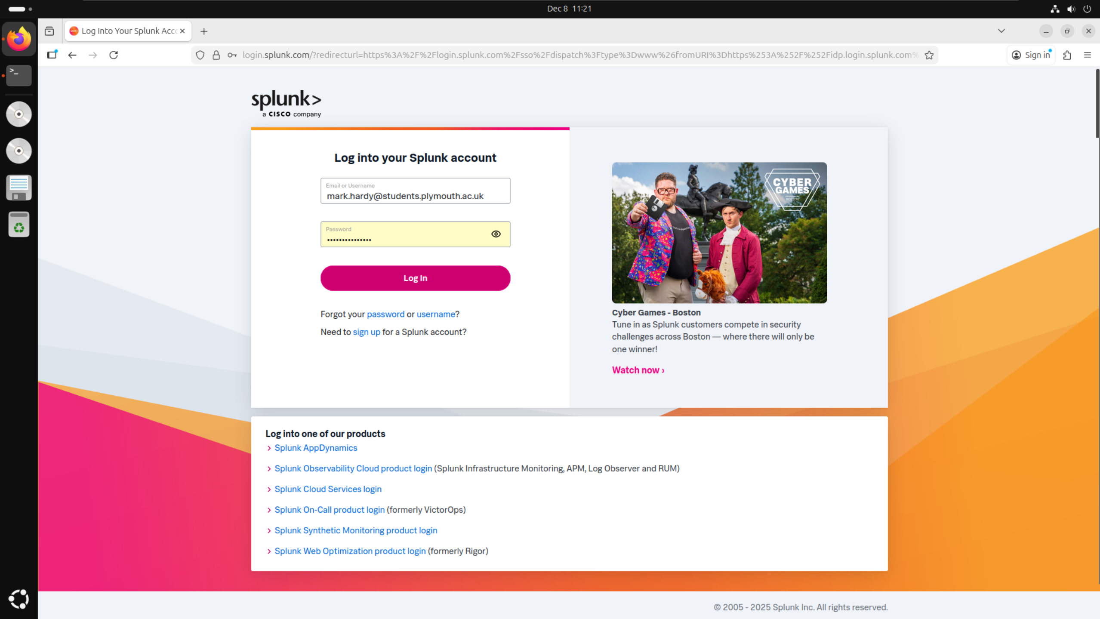

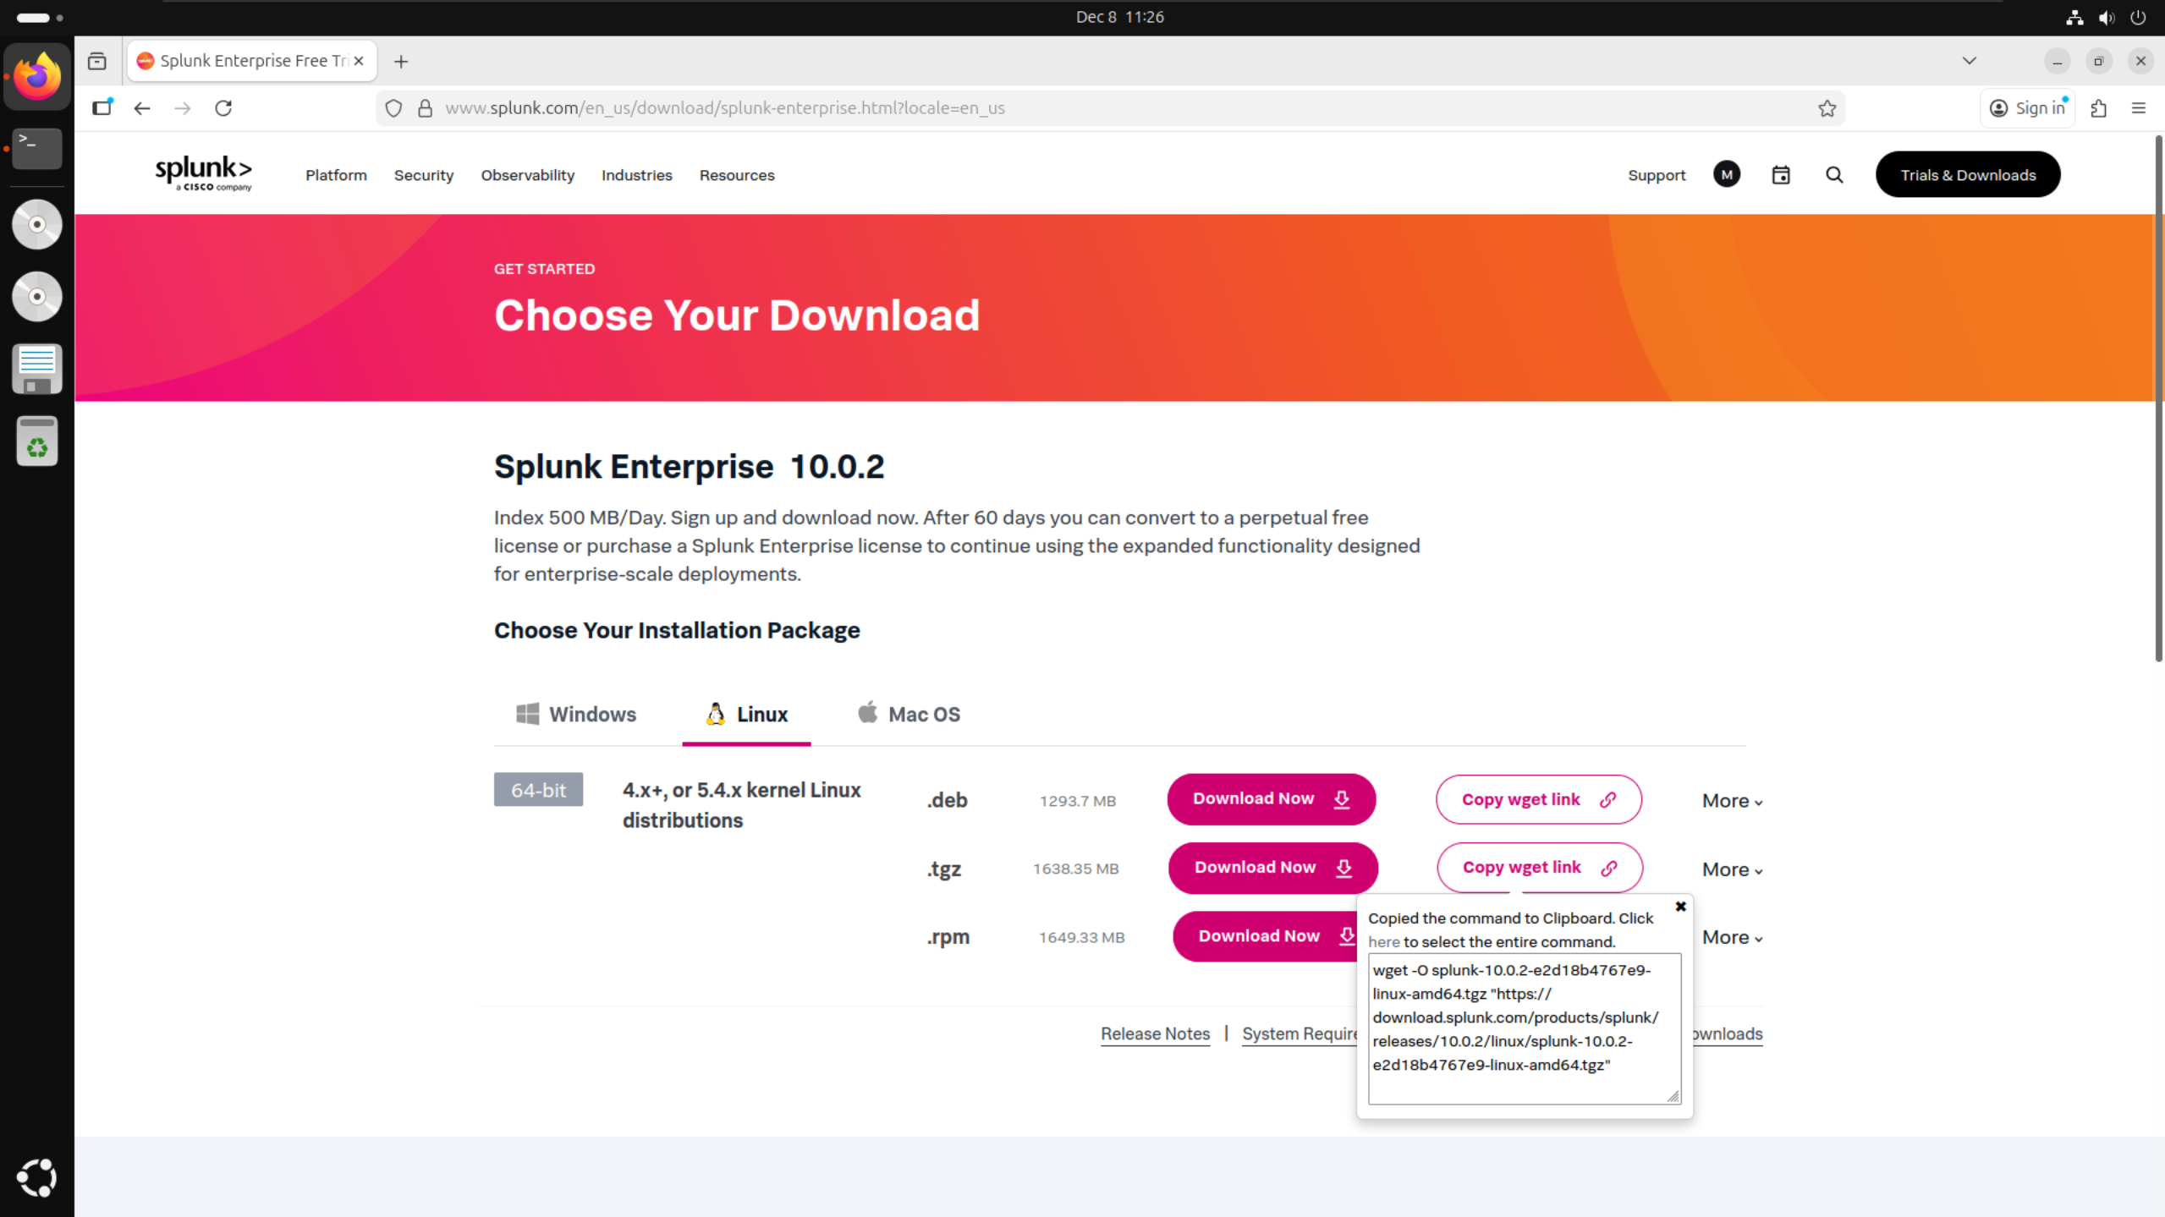

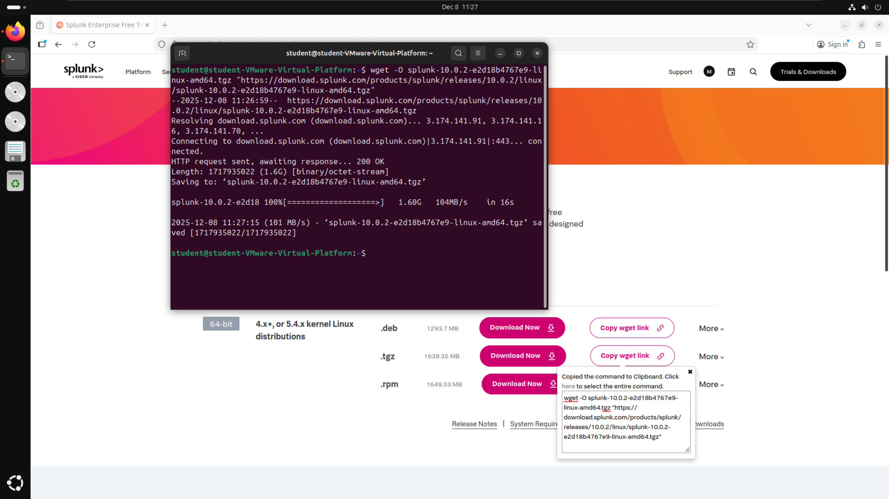

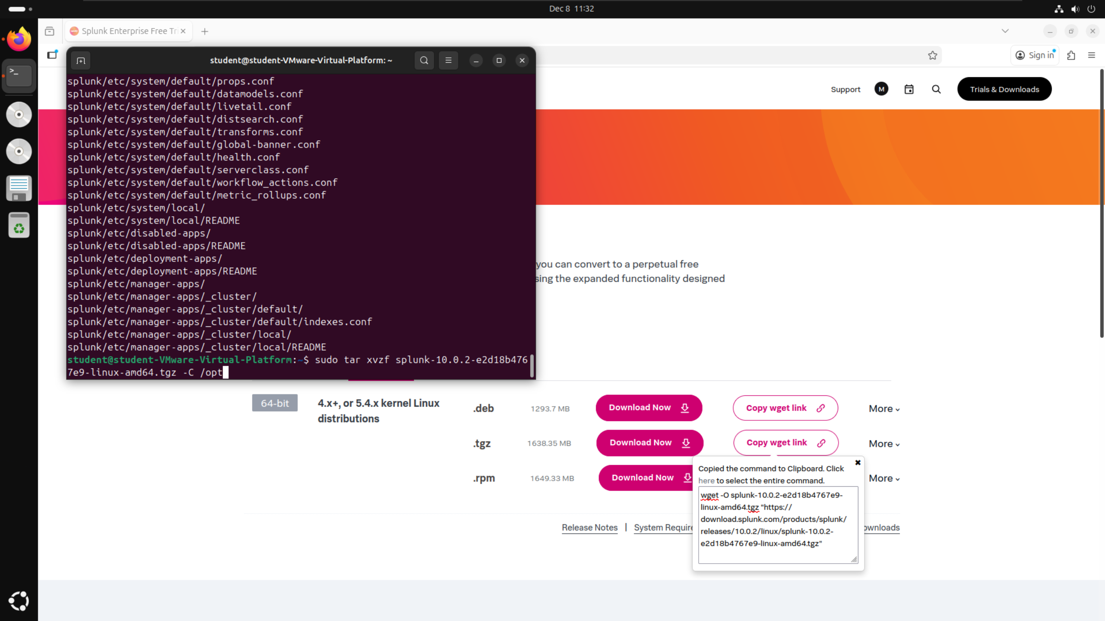

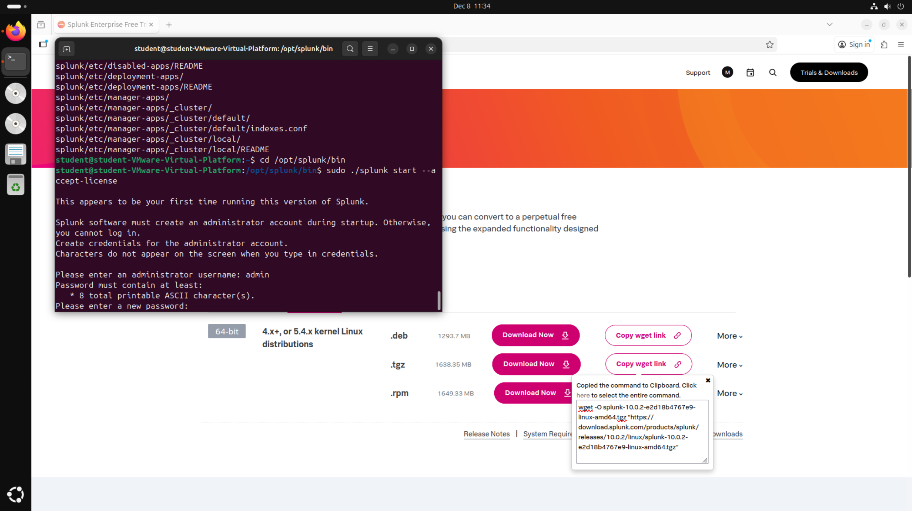

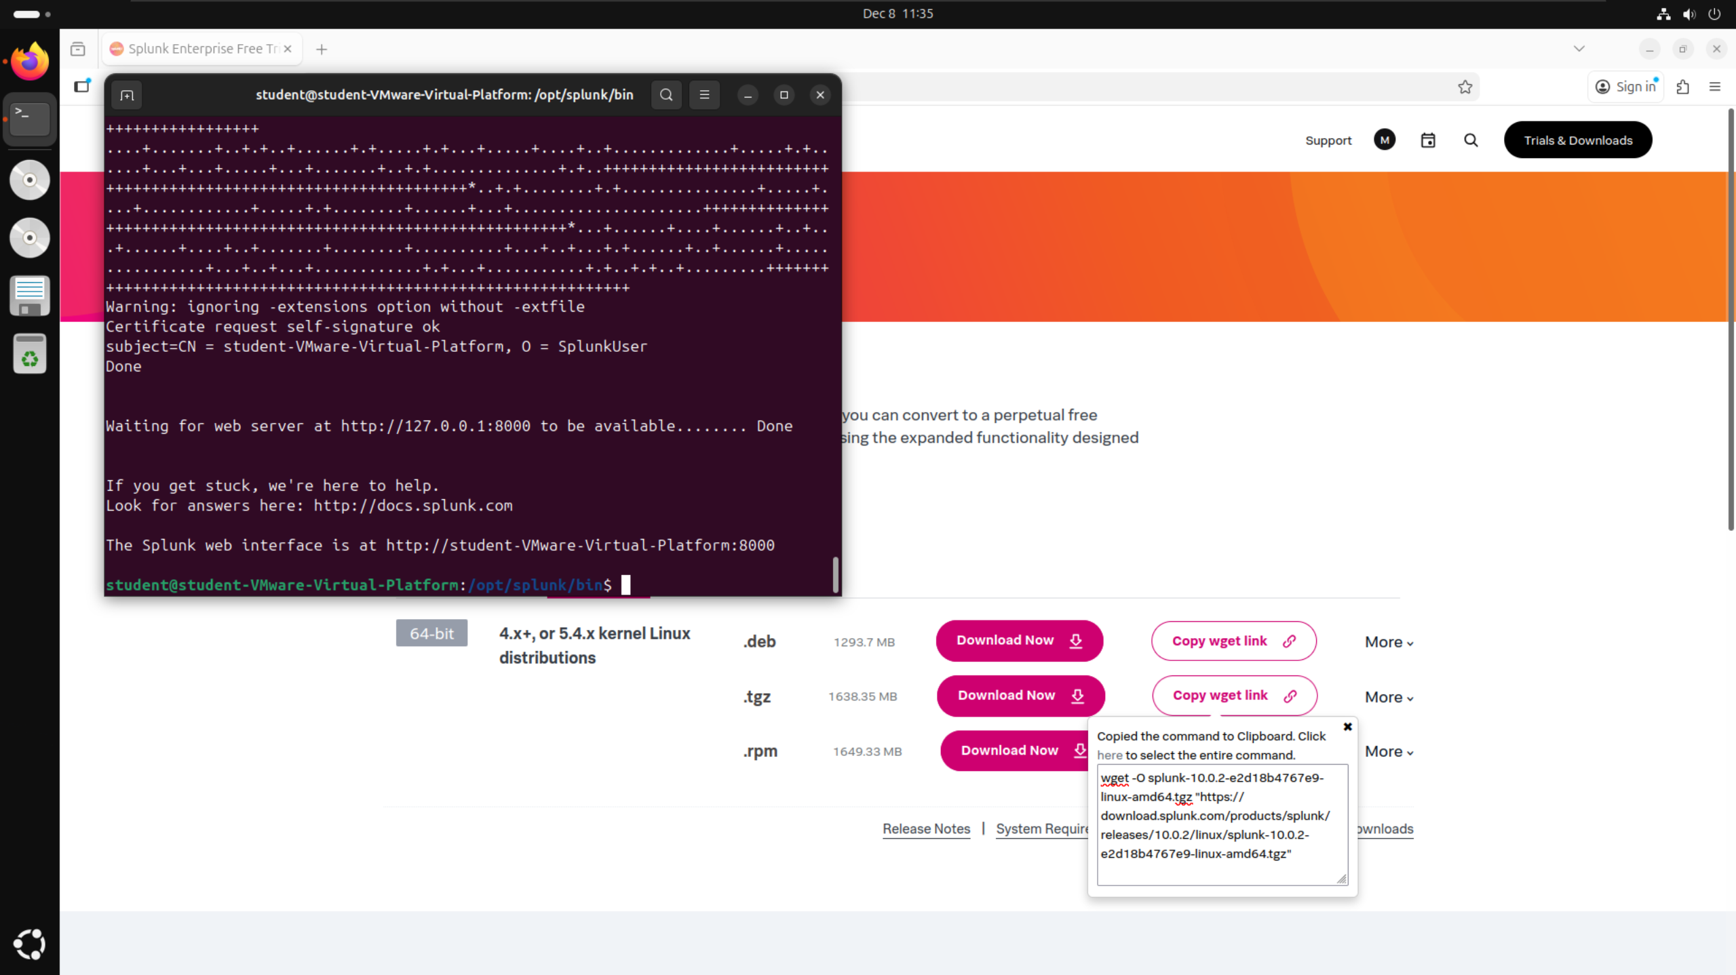

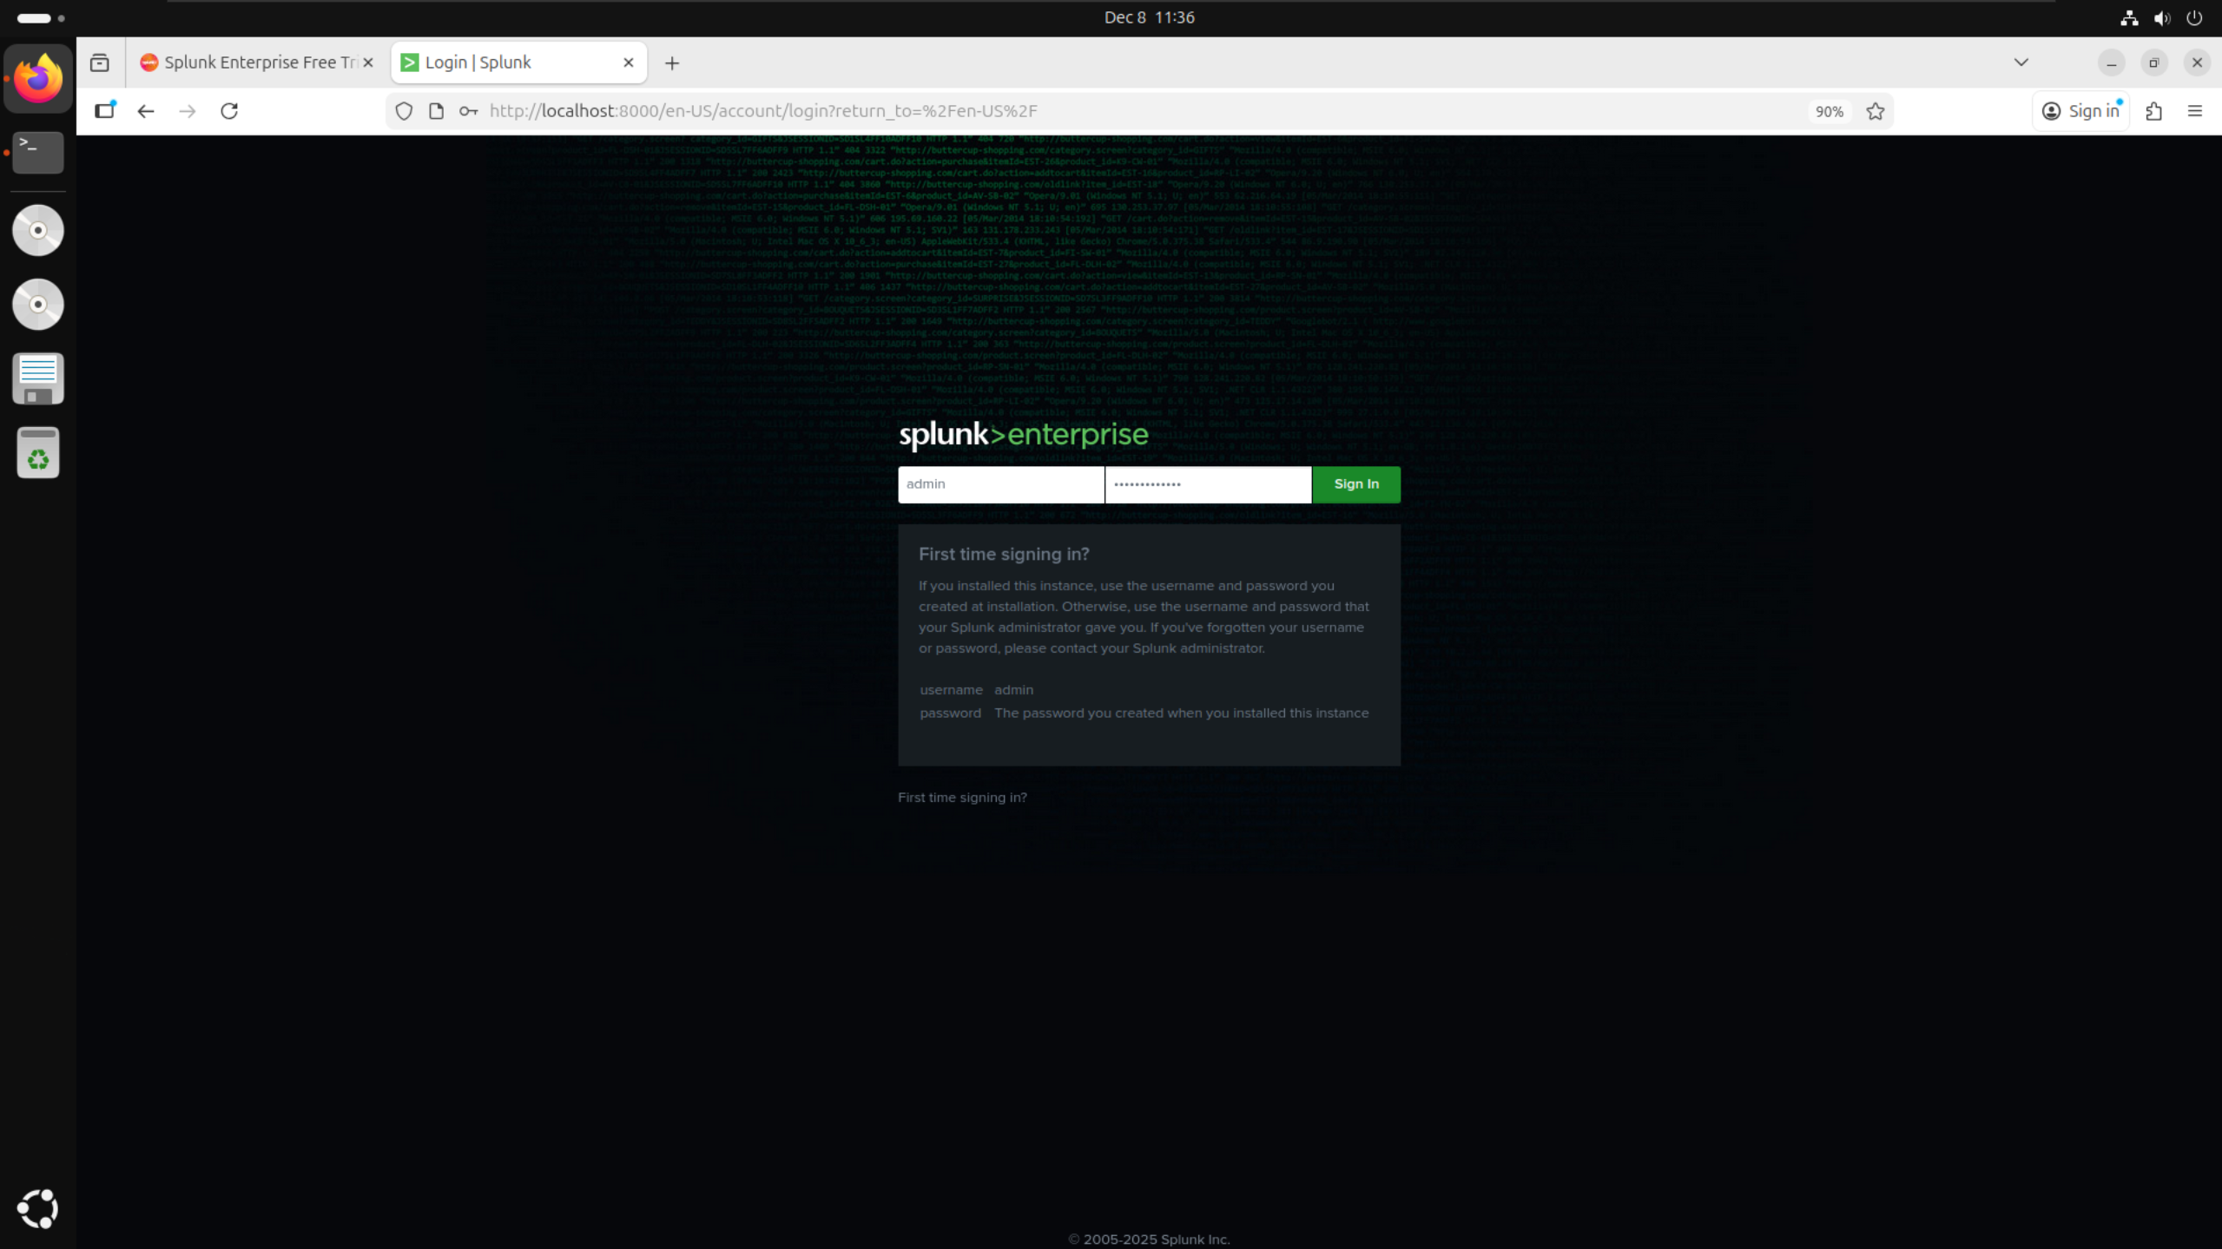

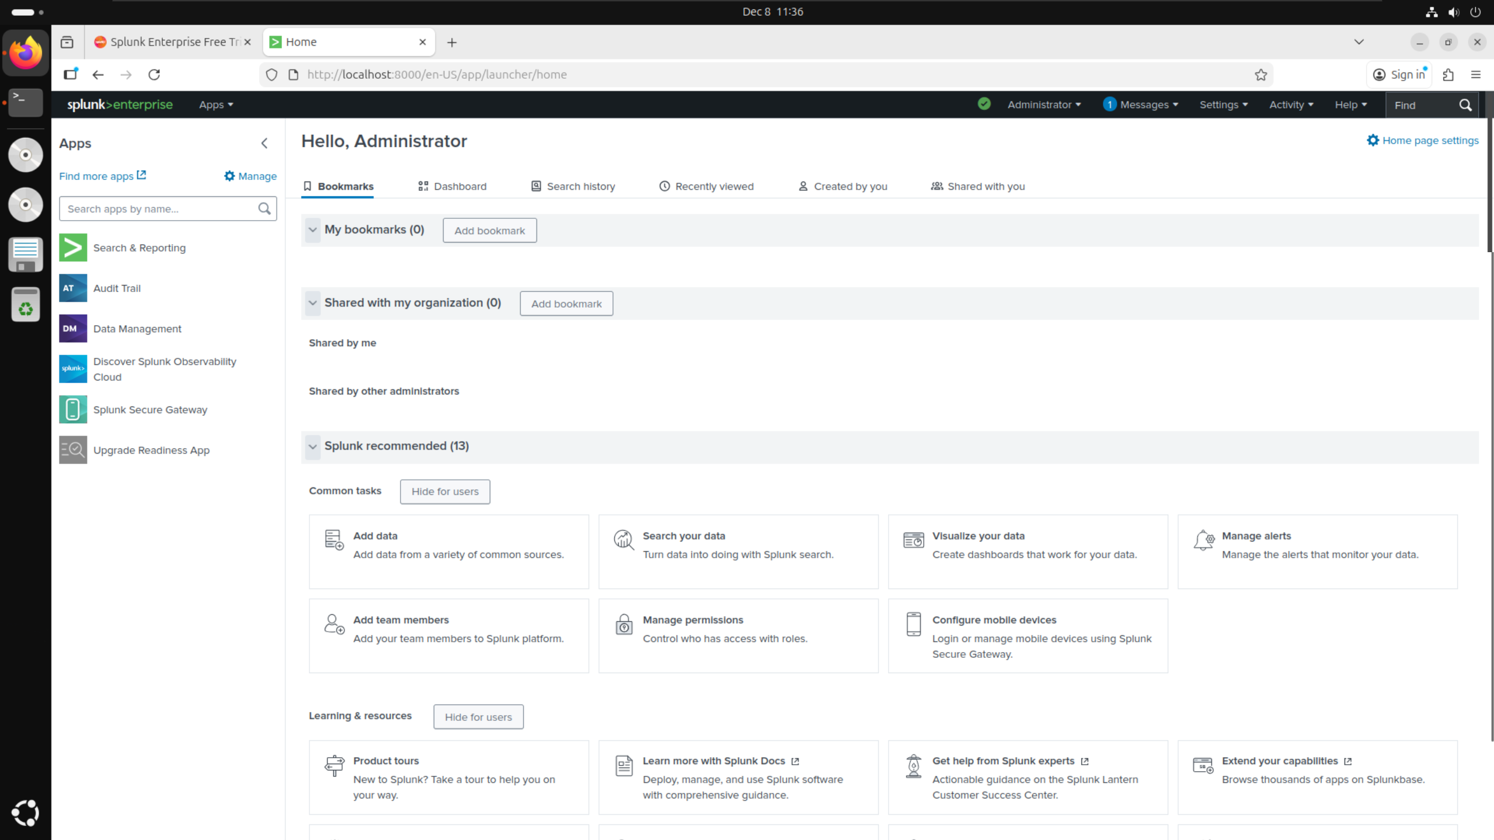

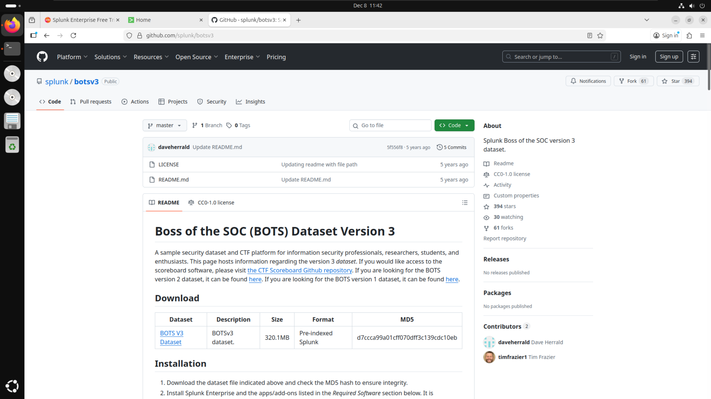

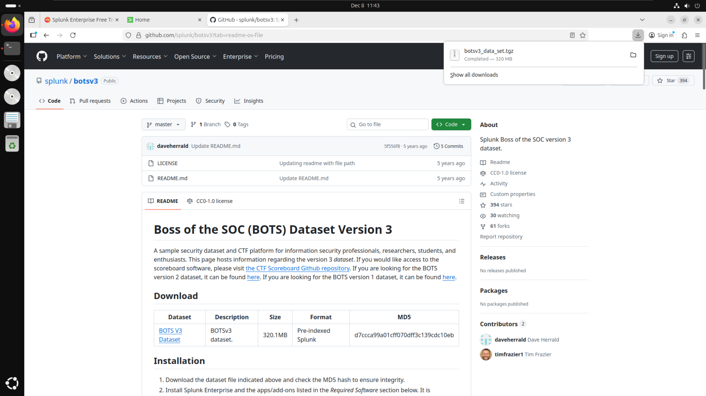

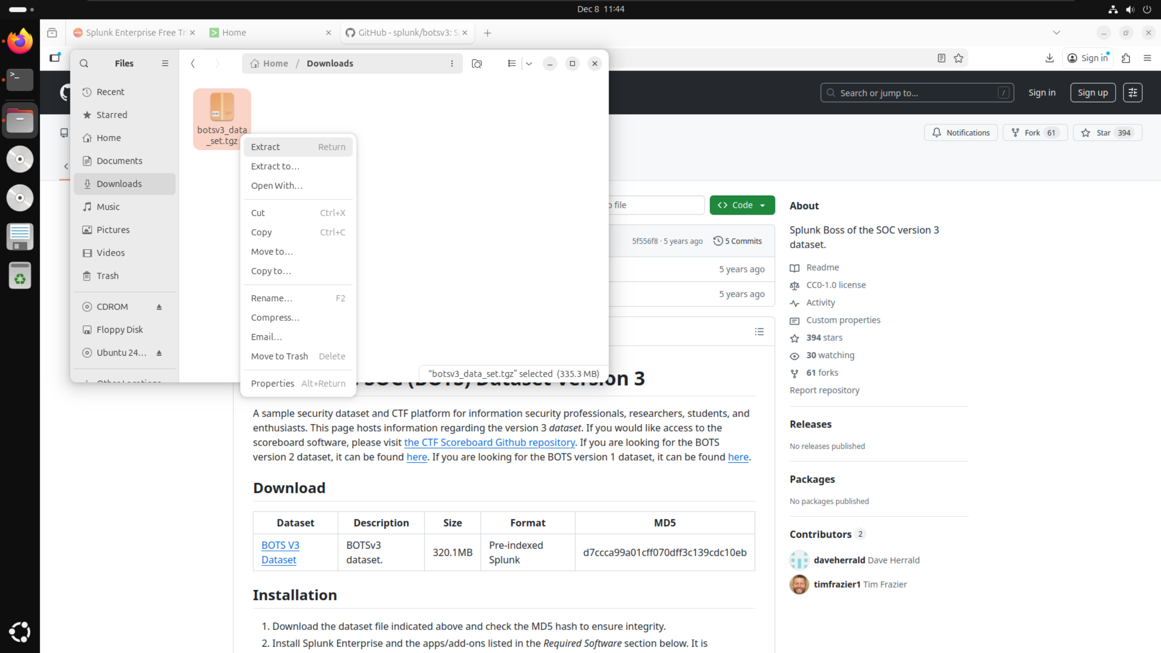

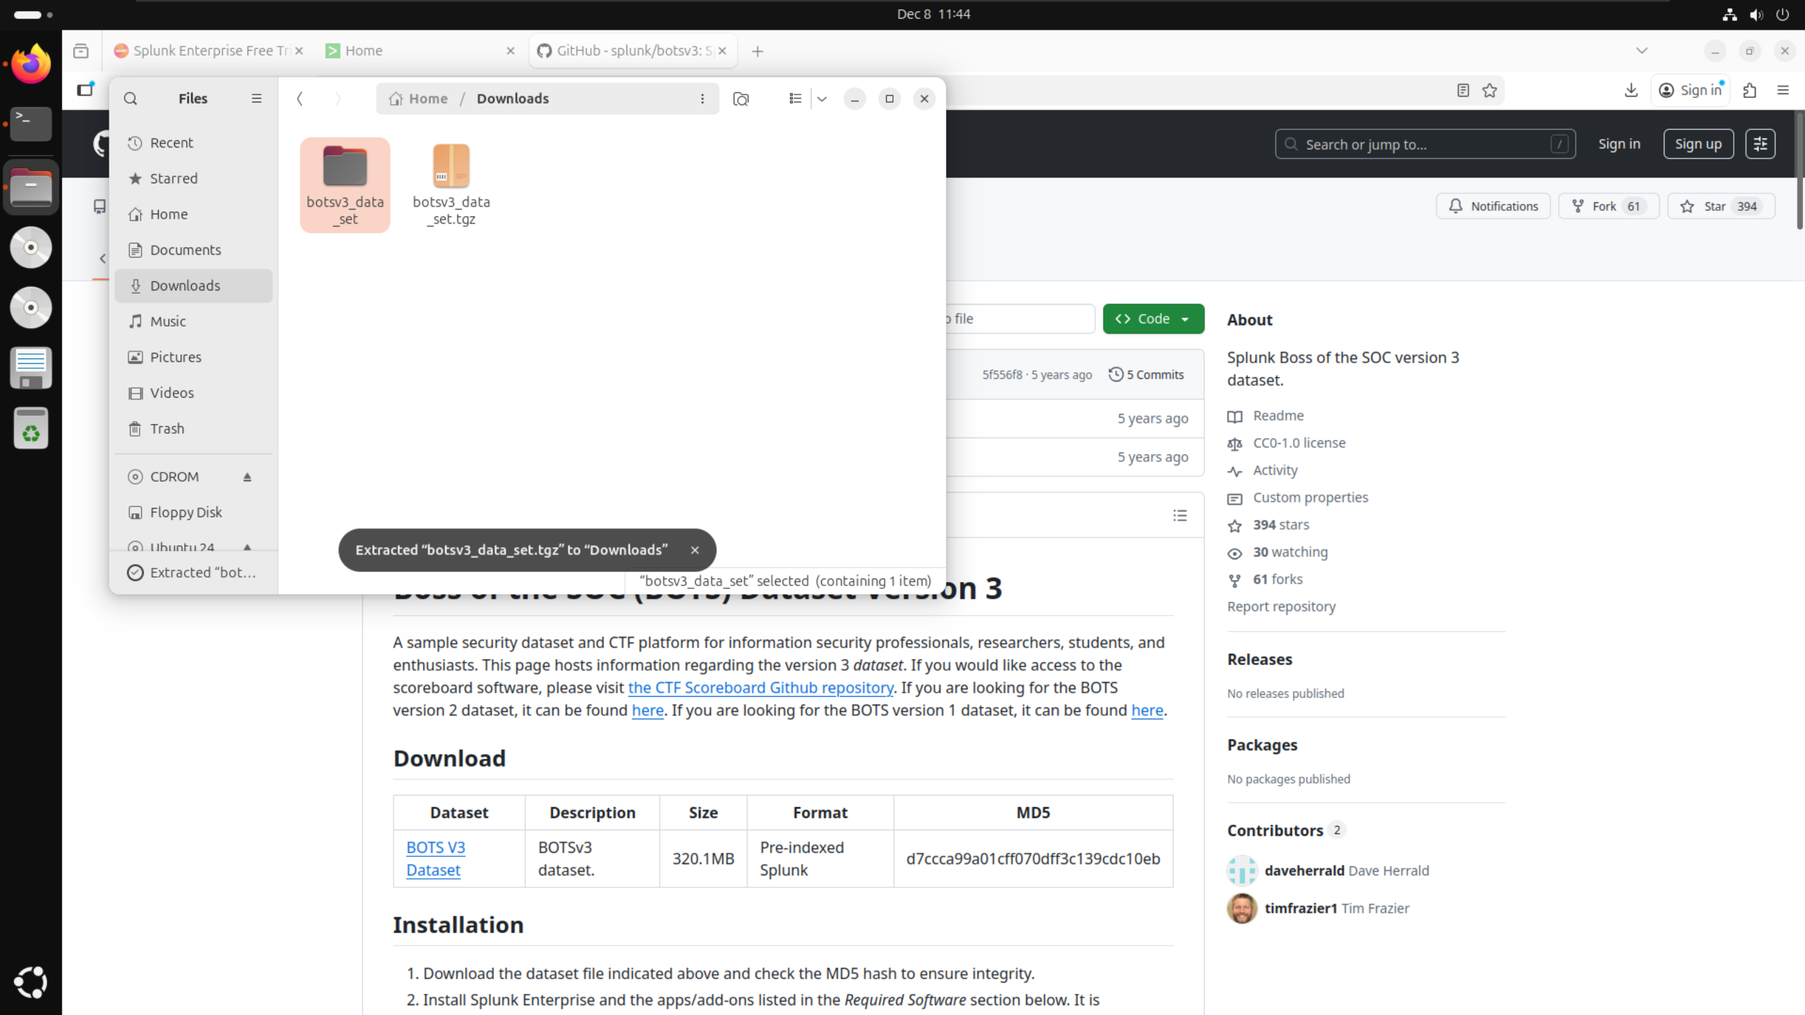

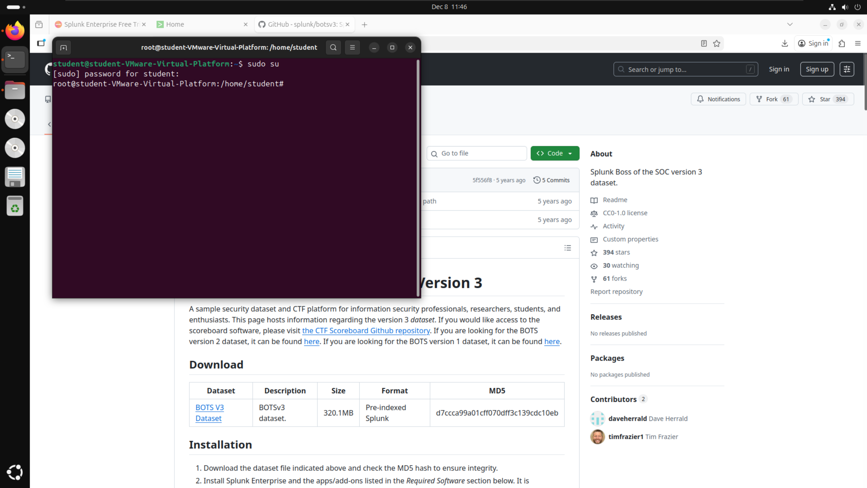

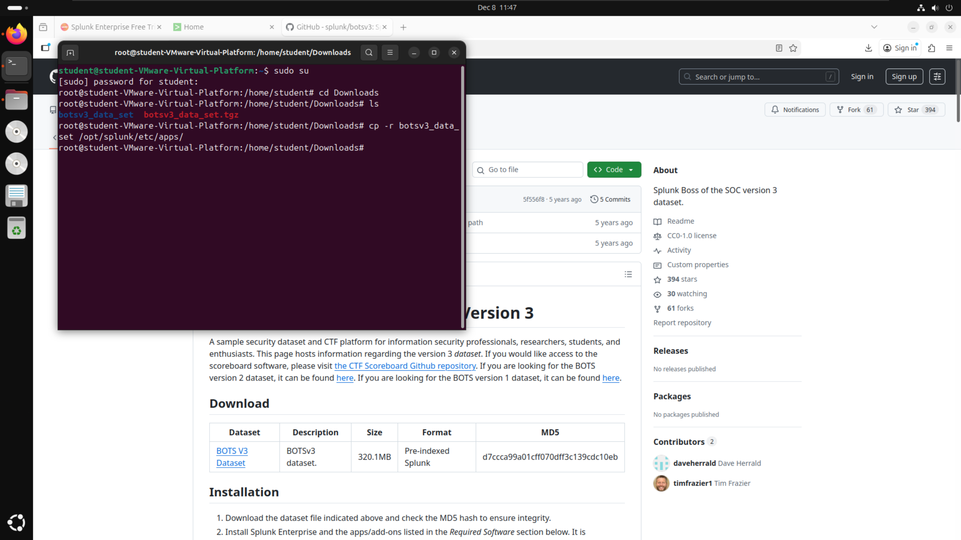

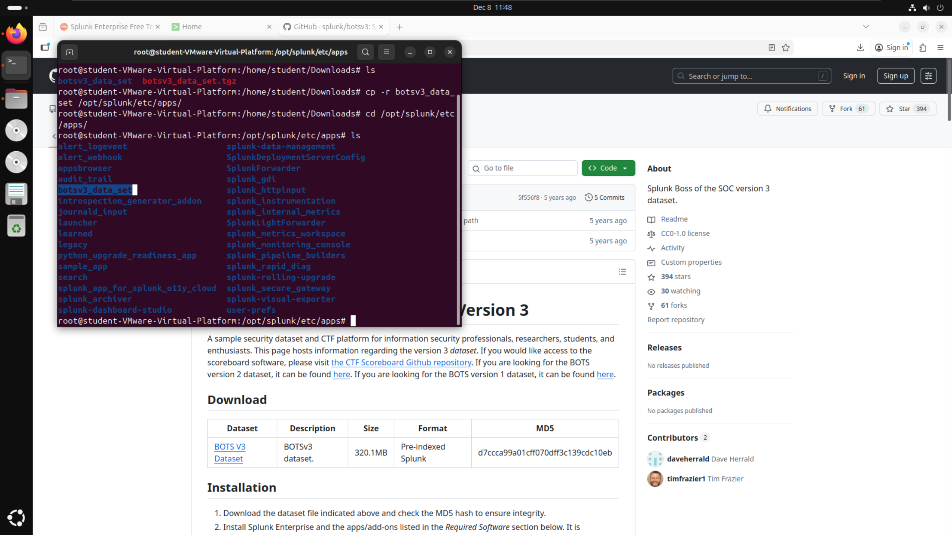

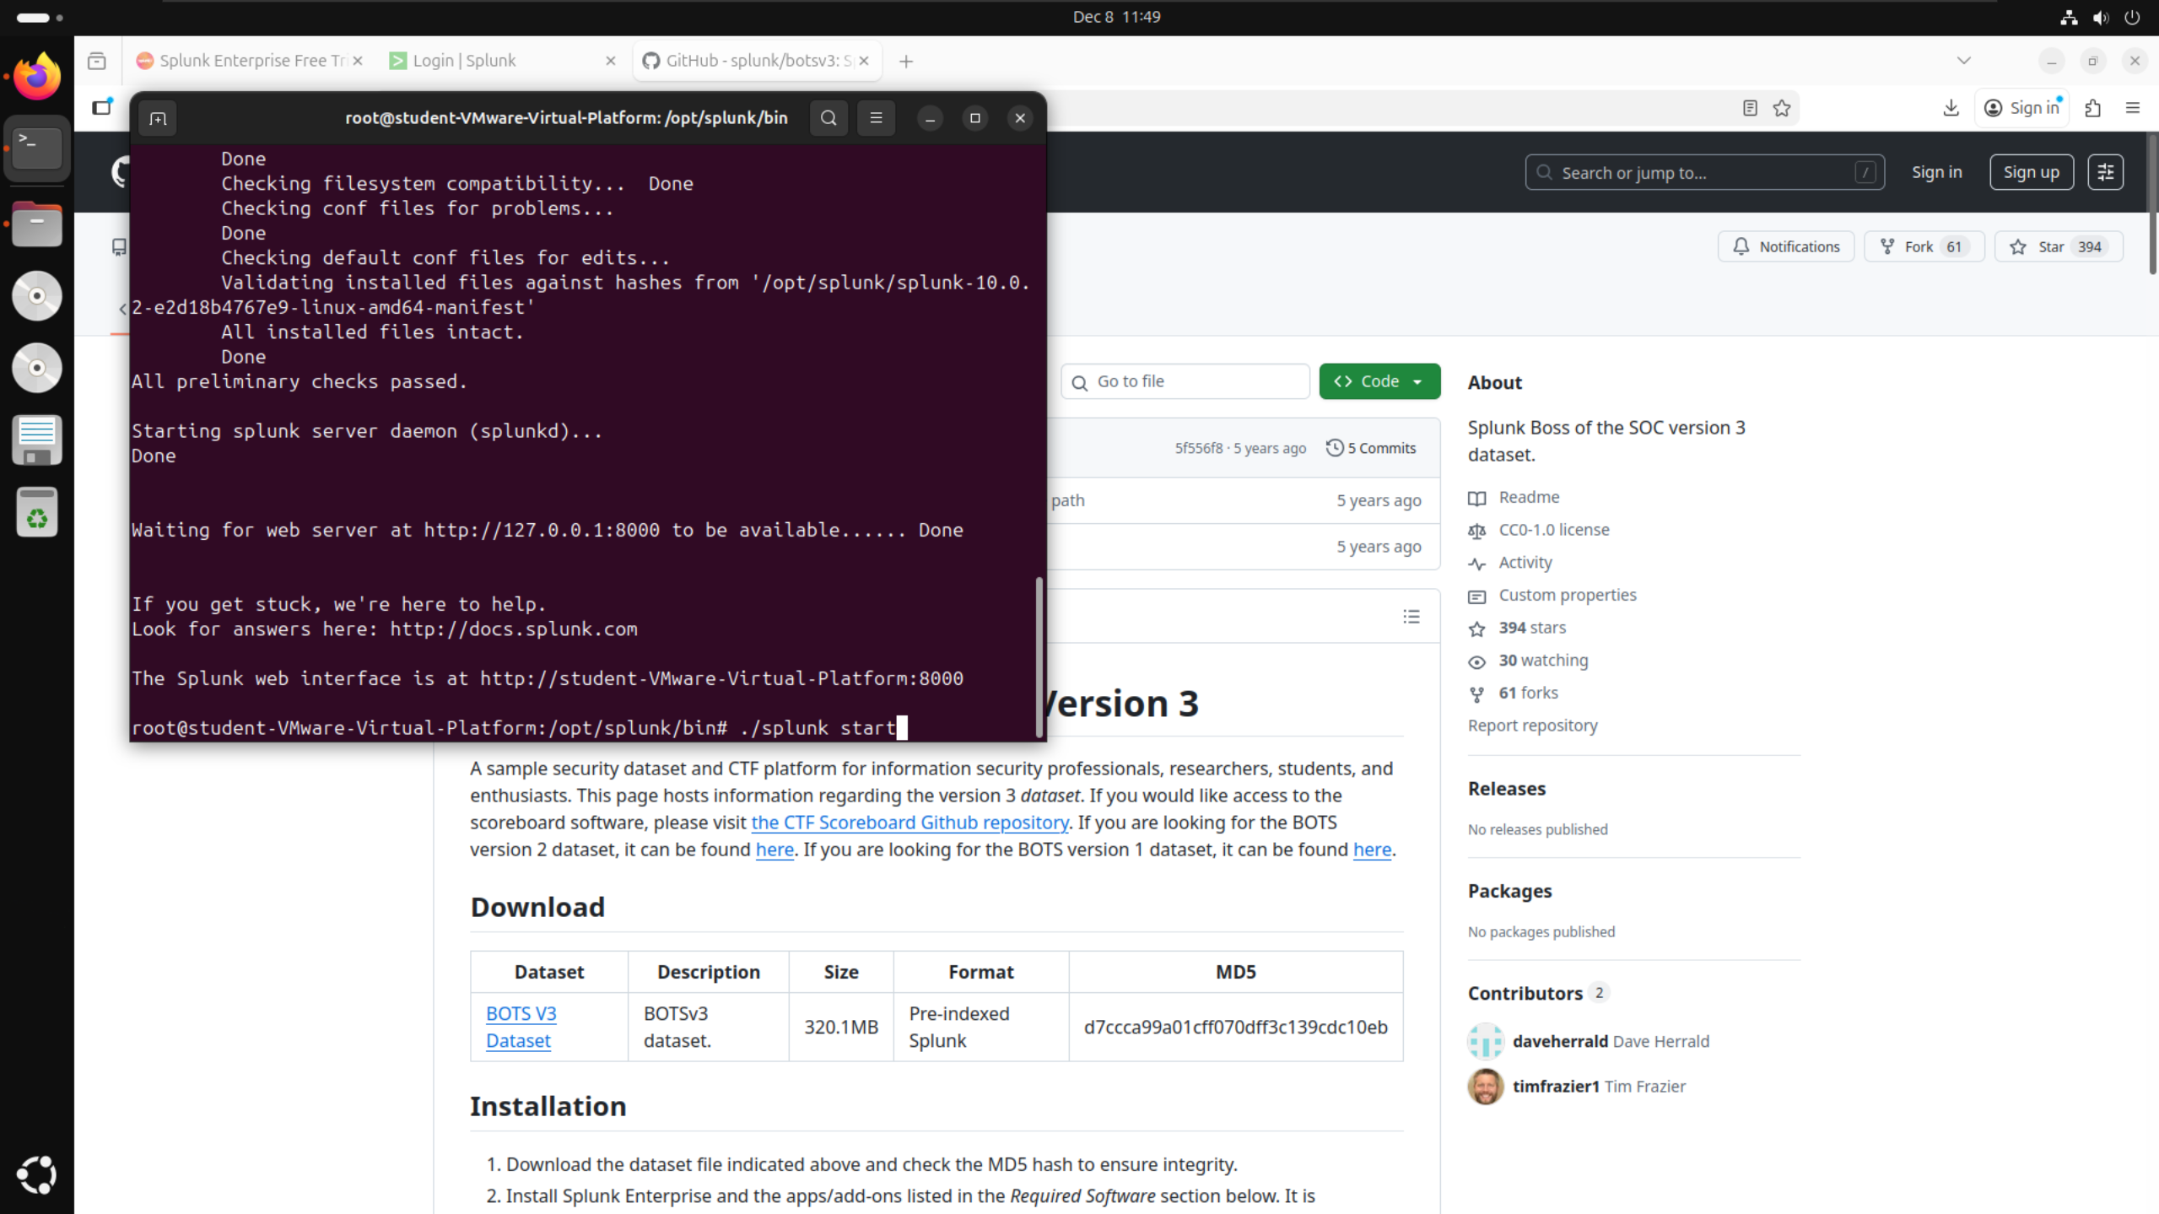

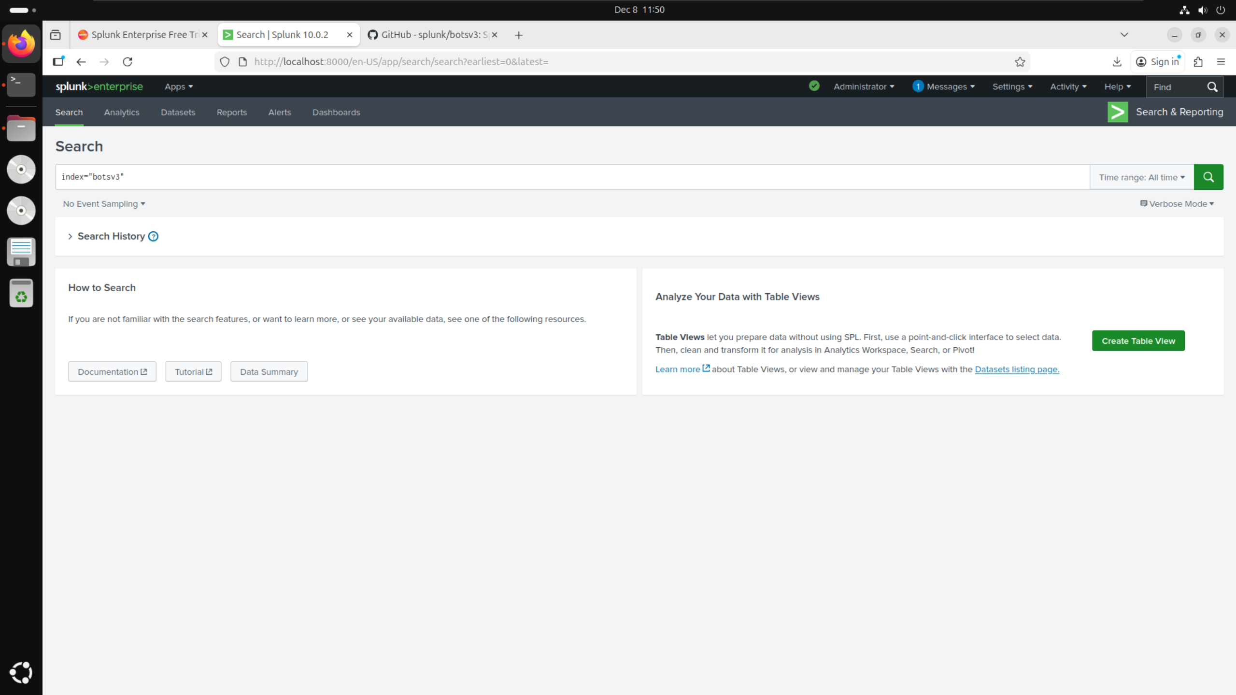

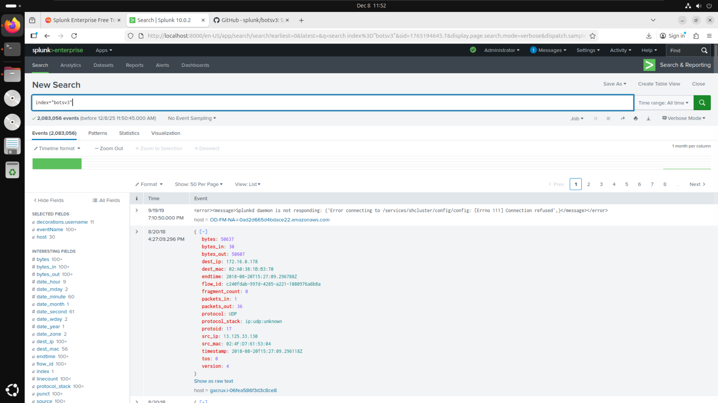

## BOTSv3 Dataset Preparation:

# Guided Questions:

## Question 1:

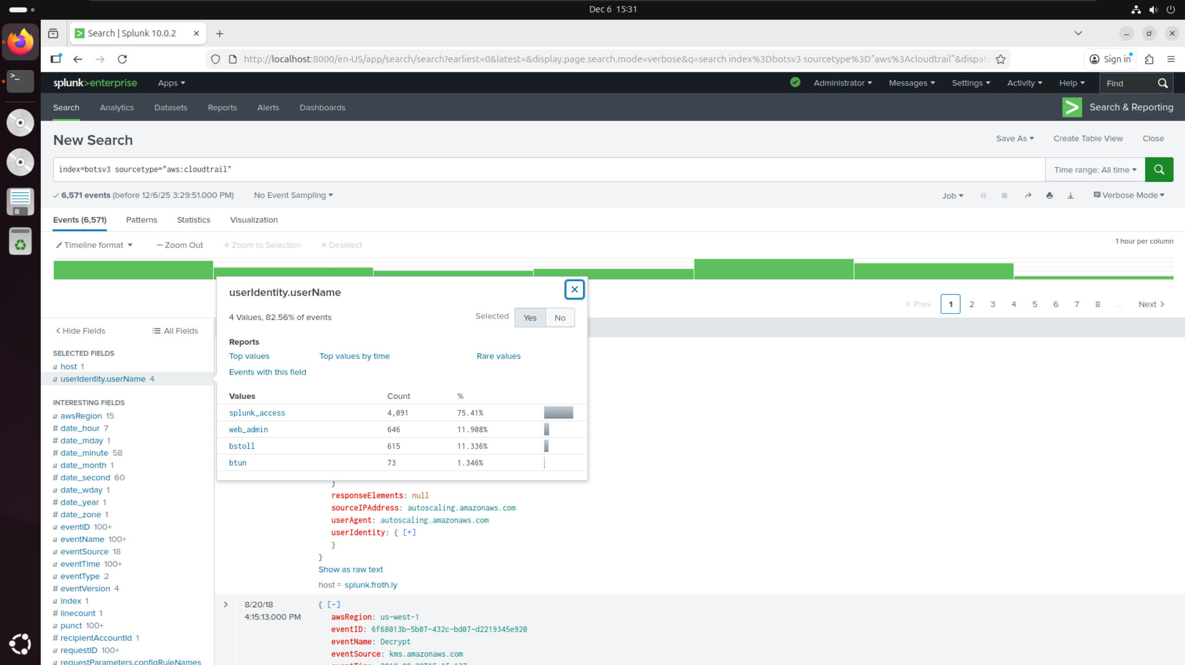

* Filtered BOTSv3 by sourcetype=”aws:cloudtrail” as given in the hints on the DLE quiz
* Searched within the filters for “username” and found userIdentity.userName filter
* Selected filter and checked values to find 4 names
* In alphabetical order: bstoll, btun, splunk_access, web_admin

## Question 2:

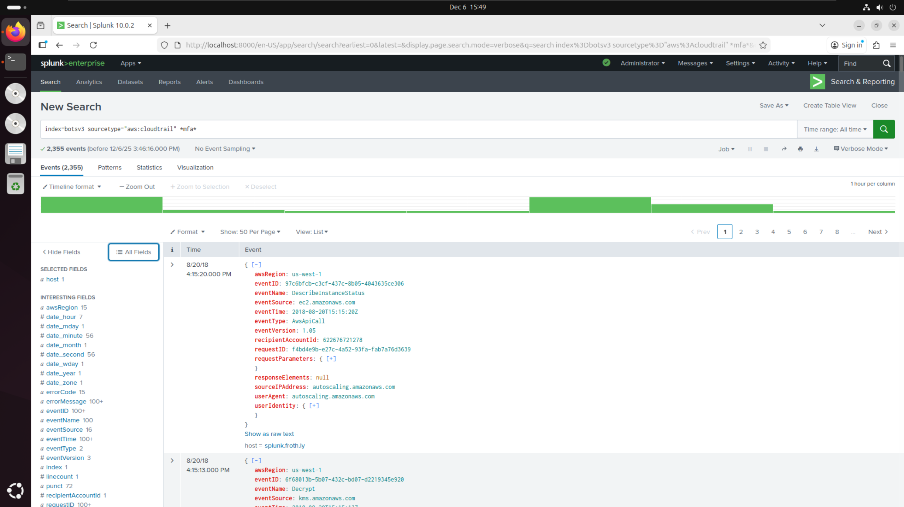

* Filtered BOTSv3 by sourcetype=”aws:cloudtrail” as given in the hints on the DLE quiz
* Added additional filter for *mfa* since looking for details relating to multi-factor authentication (using asterisks as given in the hints on the DLE quiz)

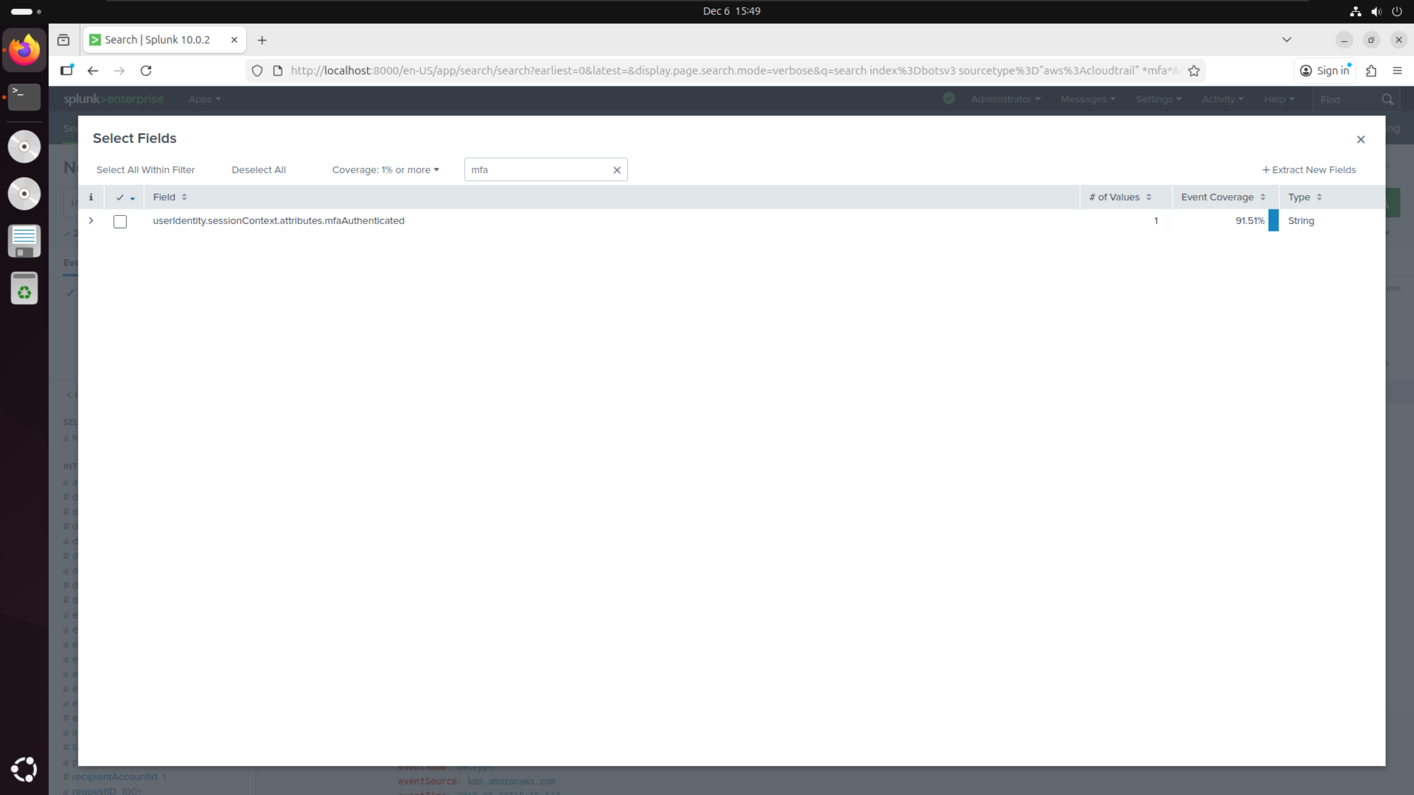

* Searched additional filters for anything related to “mfa” to find userIdentity.sessionContext.attributes.mfaAuthenticated

## Question 3:

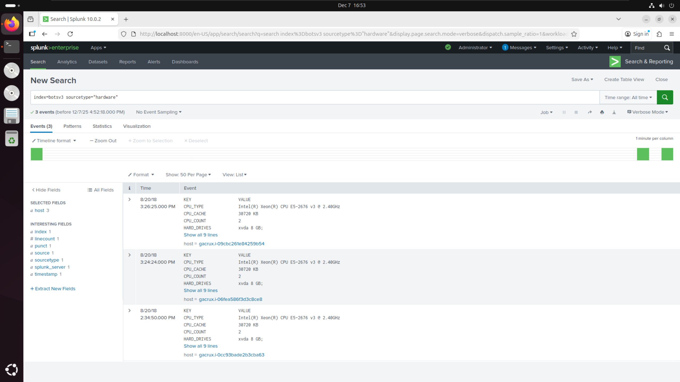

* Filtered BOTSv3 by sourcetype=”hardware” as given in the hints on the DLE quiz
* Checked value of CPU_TYPE and found the model number of E5-2676 in the correct form of **-**** given in the hints on the DLE quiz

## Question 4:

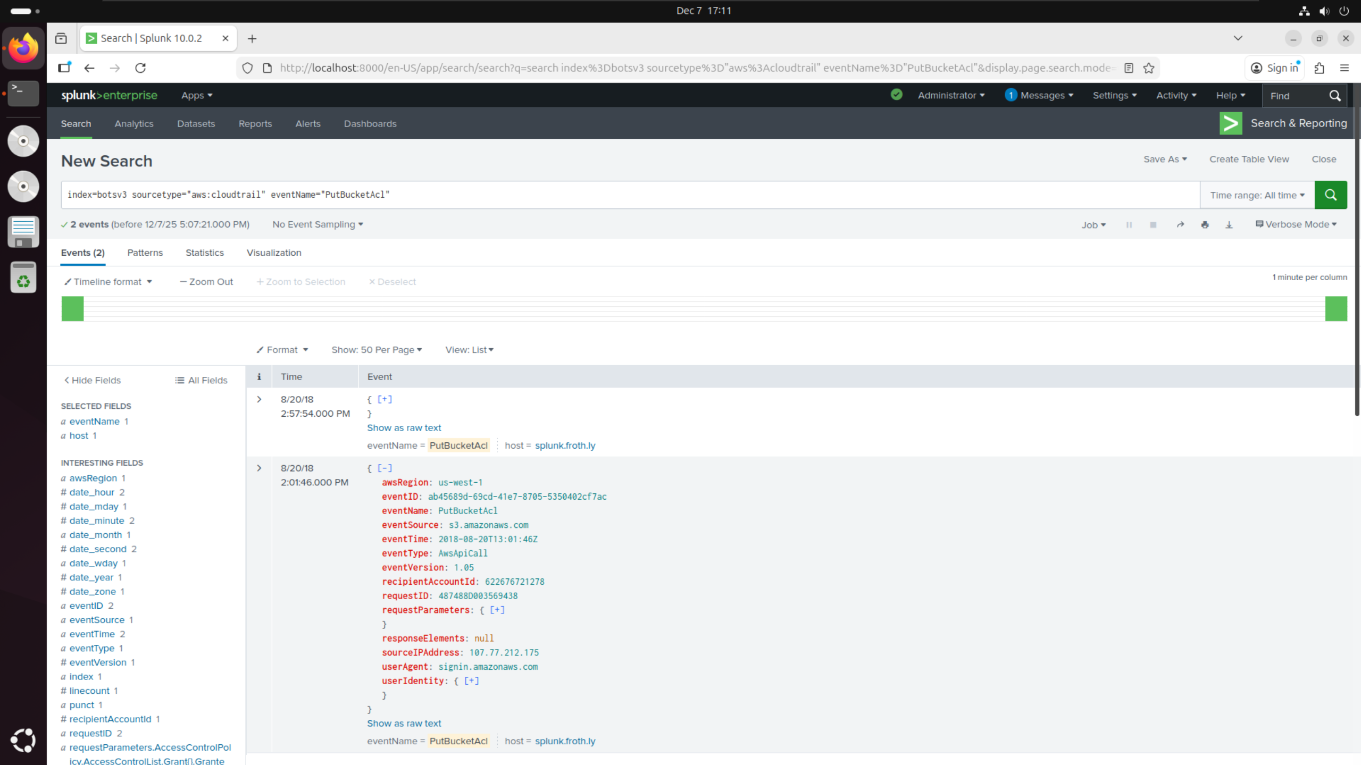

* Filtered BOTSv3 by sourcetype=”aws:cloudtrail” and specific eventName=”PutBucketAcl” as given in the hints on the DLE quiz
* Noticed 2 events with this event name but different event IDs
* Assumed these events would be user accidentally making the S3 bucket public (older event) then making it private again (newer event) giving the correct eventID as ab45689d-69cd-41e7-8705-5350402cf7ac

## Question 5:

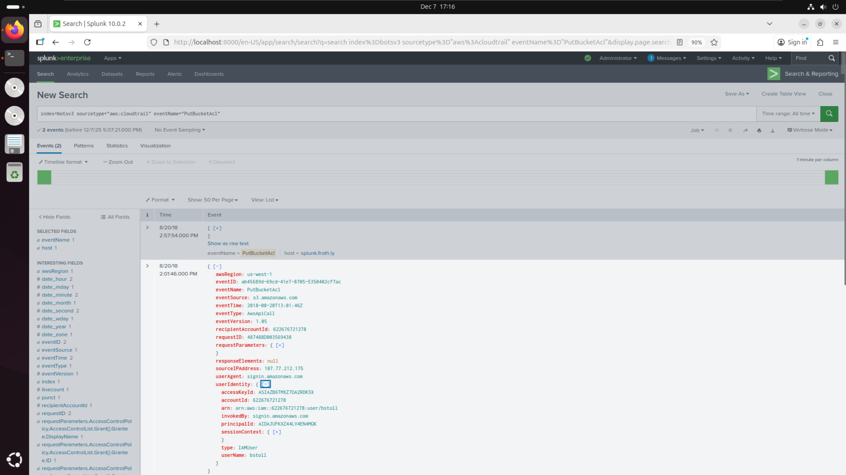

* Applied same filters as question 4
* Opened userIdentity field within the relevant event and found userName: bstoll

## Question 6:

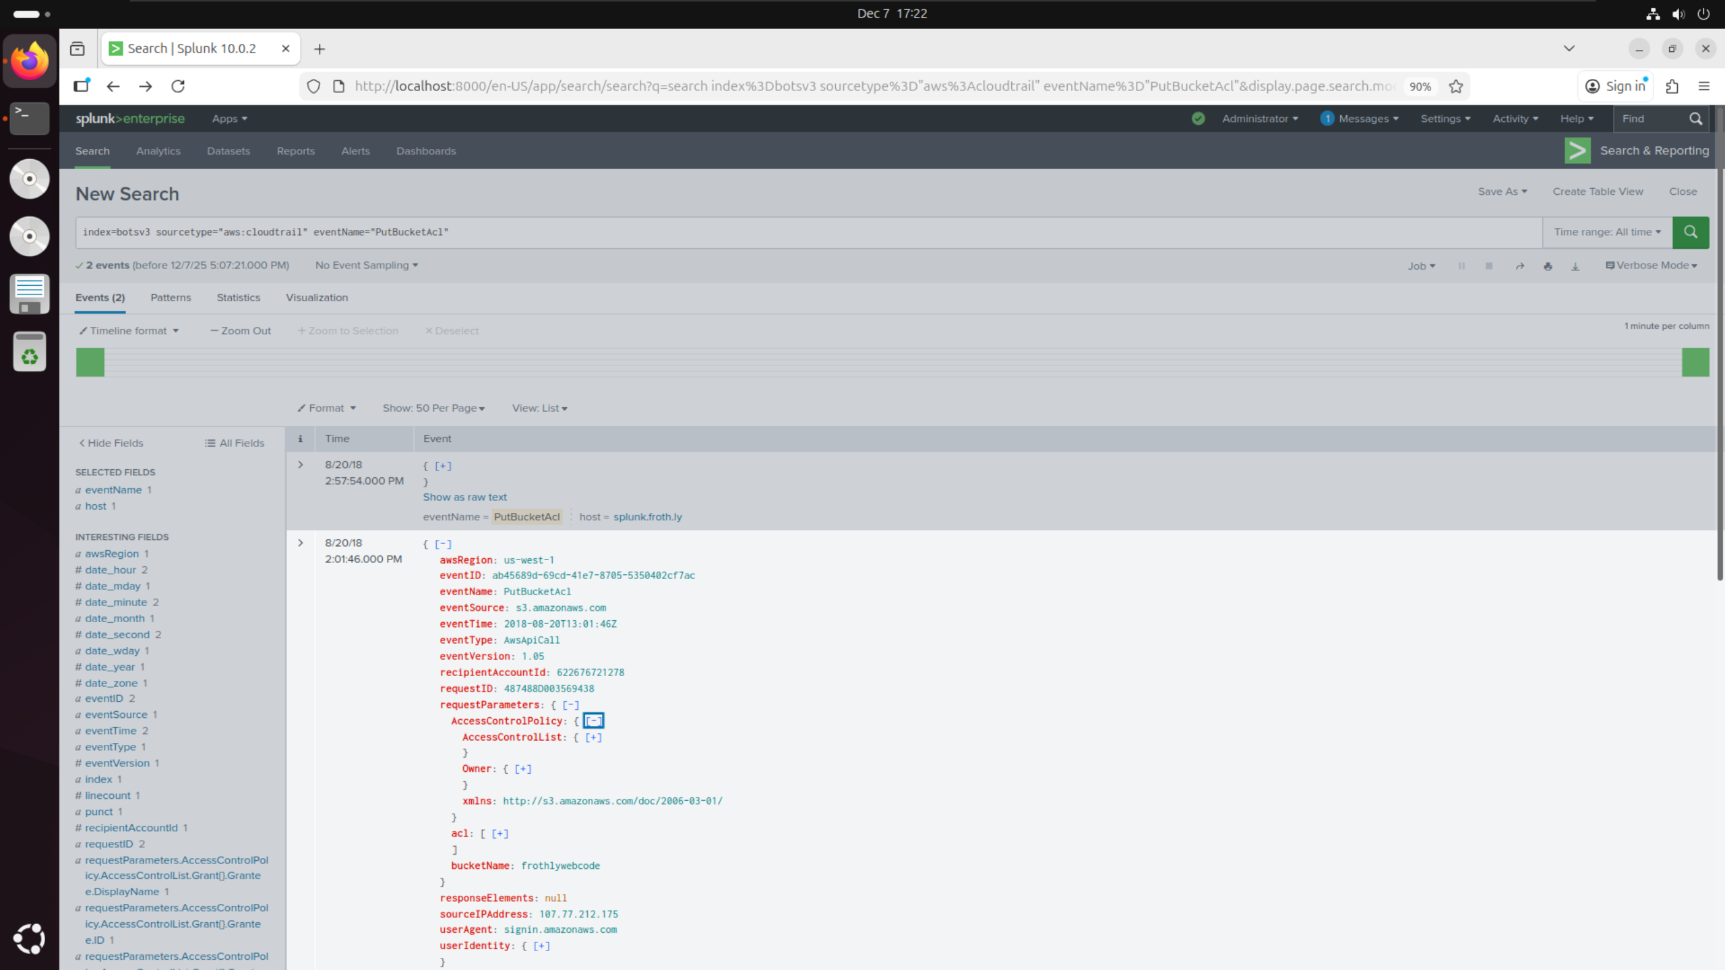

* Applied same filters as question 4
* Opened requestParameters field within the relevant event and found bucketName: frothlywebcode

## Question 7:

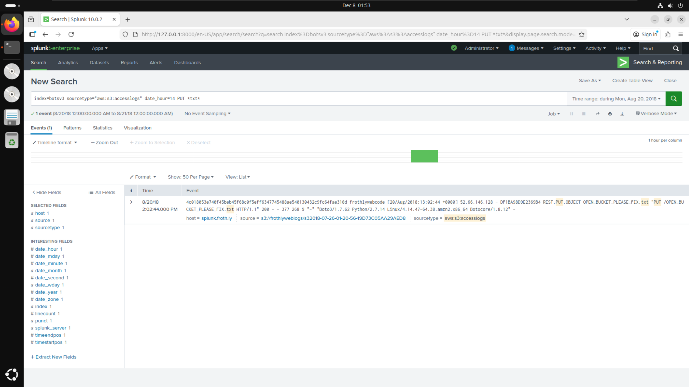

* Filtered BOTSv3 by sourcetype=”aws:s3:accesslogs” as given in the hints on the DLE quiz
* Filtered specifically for events at date_hour=14 since questions 4-6 show both events occur between 2pm
* Filtered for PUT requests as suggested by the question since this event involved uploading a file to the bucket
* Filtered for *txt* since the question asked for the name of the text file uploaded therefore hinting it would be a .txt extension

## Question 8:

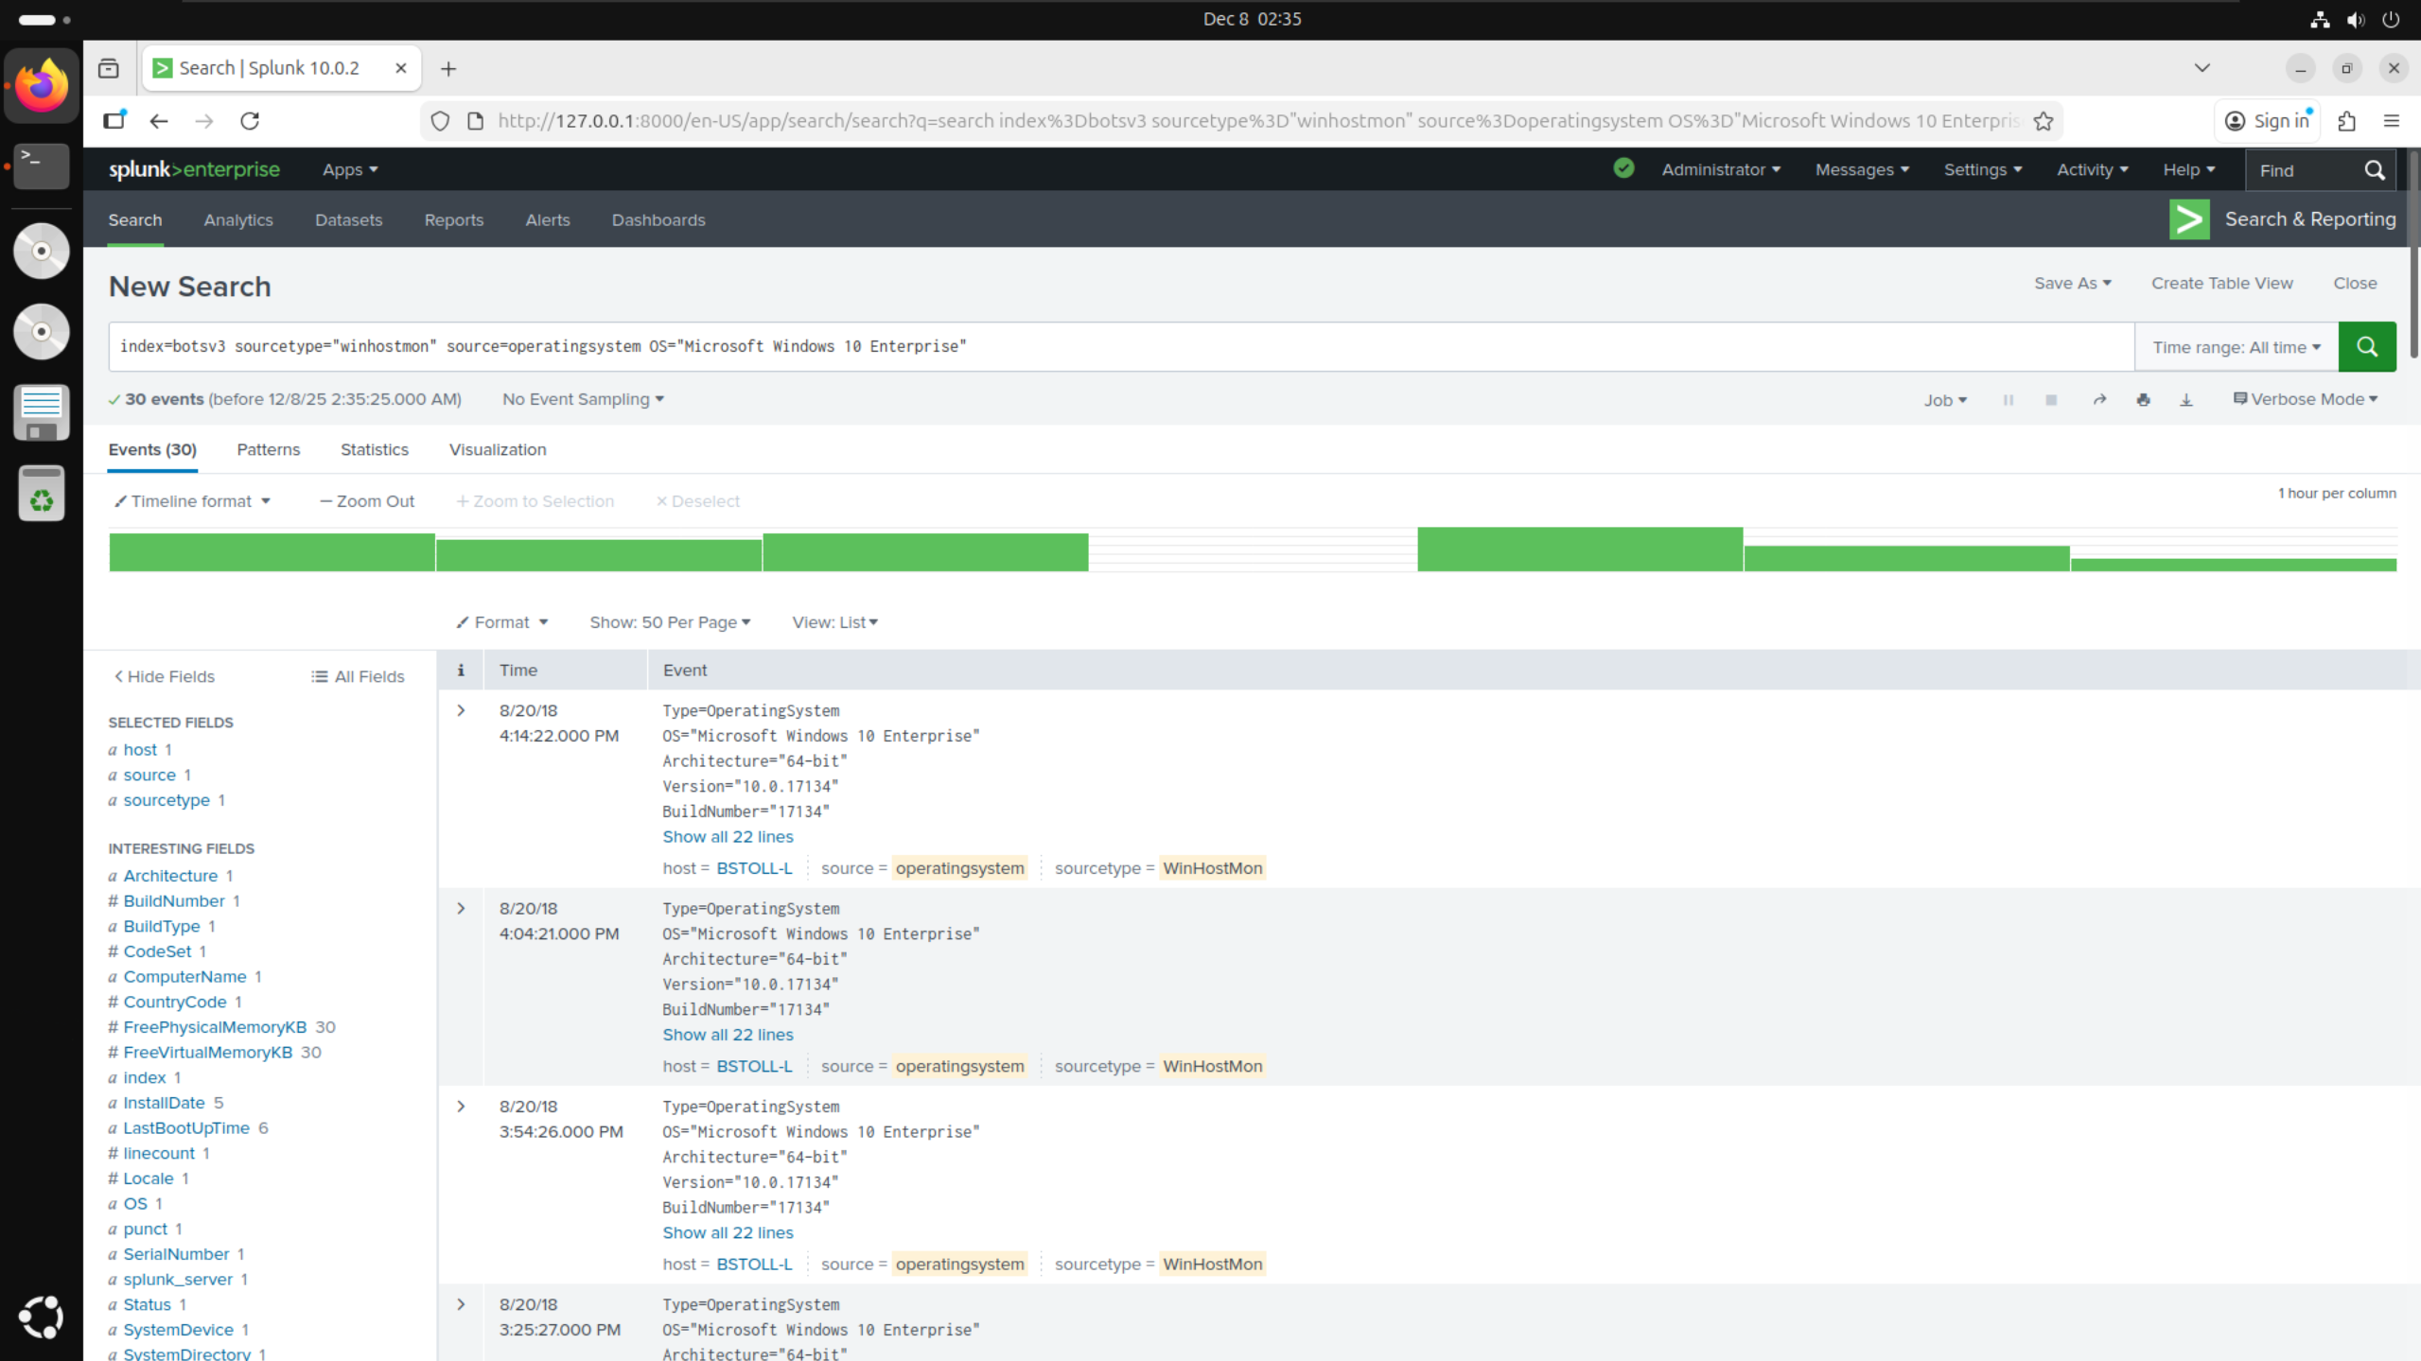

* Filtered BOTSv3 by sourcetype=”winhostmon” as given in the hints on the DLE quiz
* Searched though the filters list to find source filter and selected source=”operatingsystem” from the list
* Searched through the filters list again to find OS filter and selected OS=”Microsoft Windows 10 Enterprise” from the list as it had the least uses -> Was used 30 times by only one user

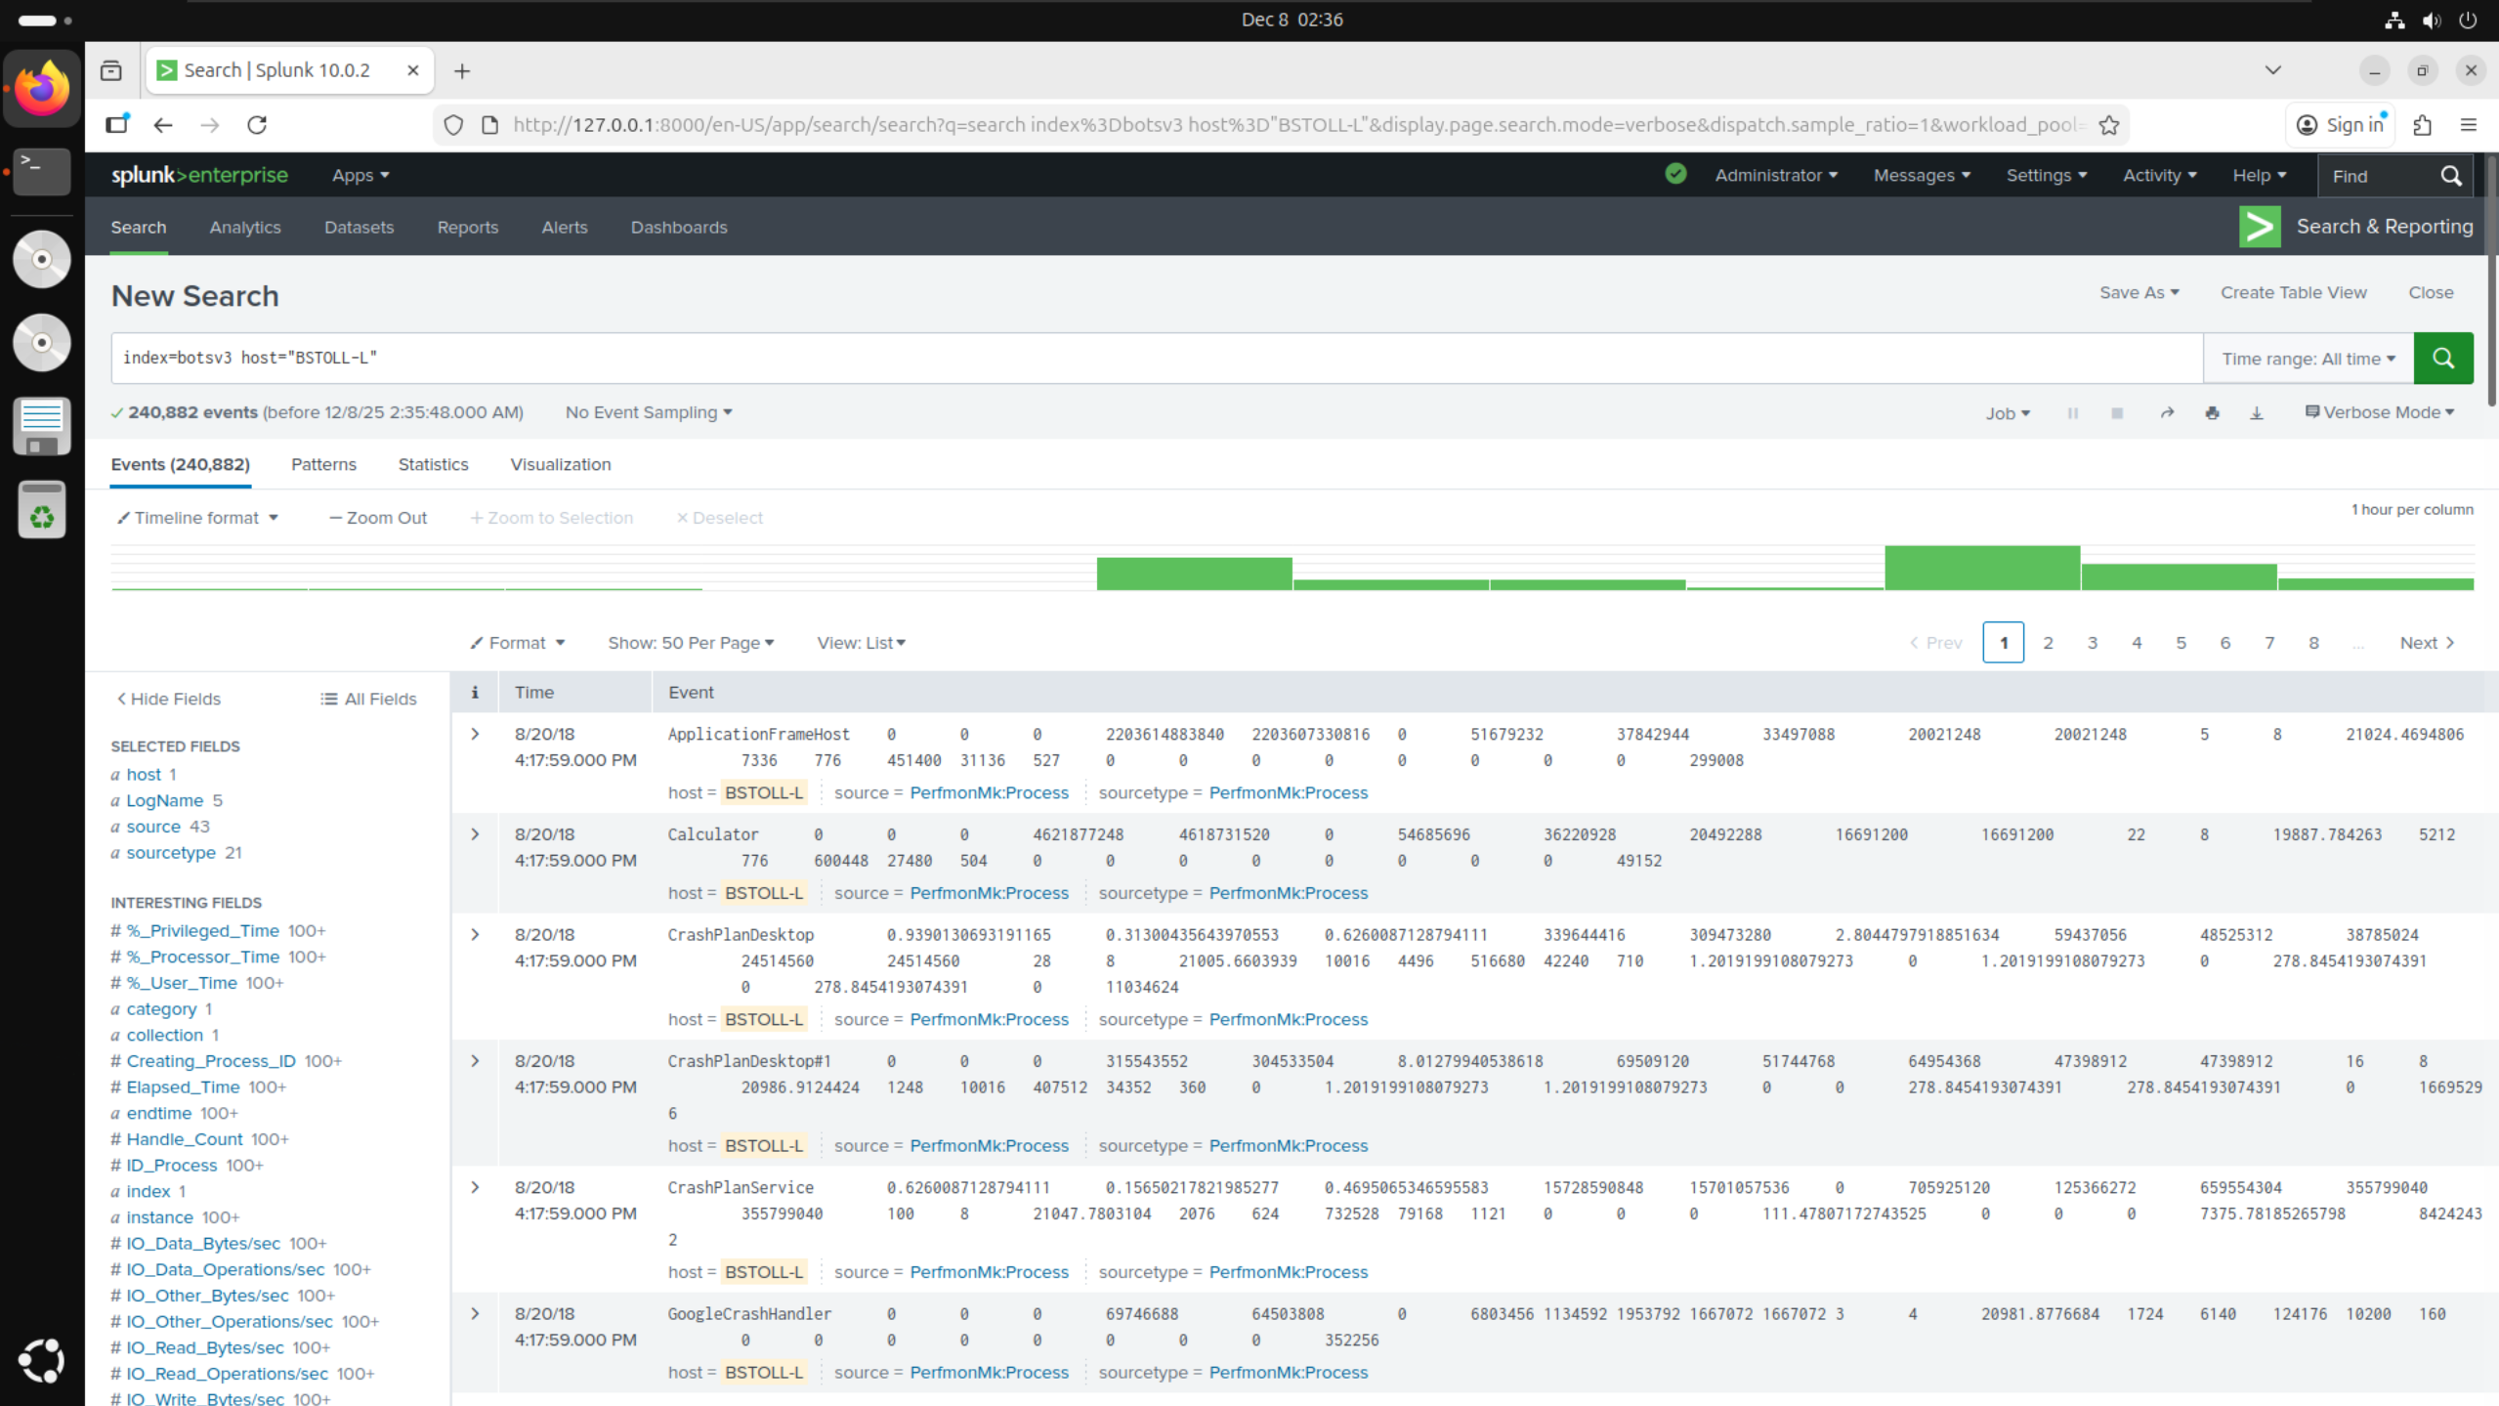

* Added host=”BSTOLL-L” from the initial search into a new search to look for any filters with the FQDN

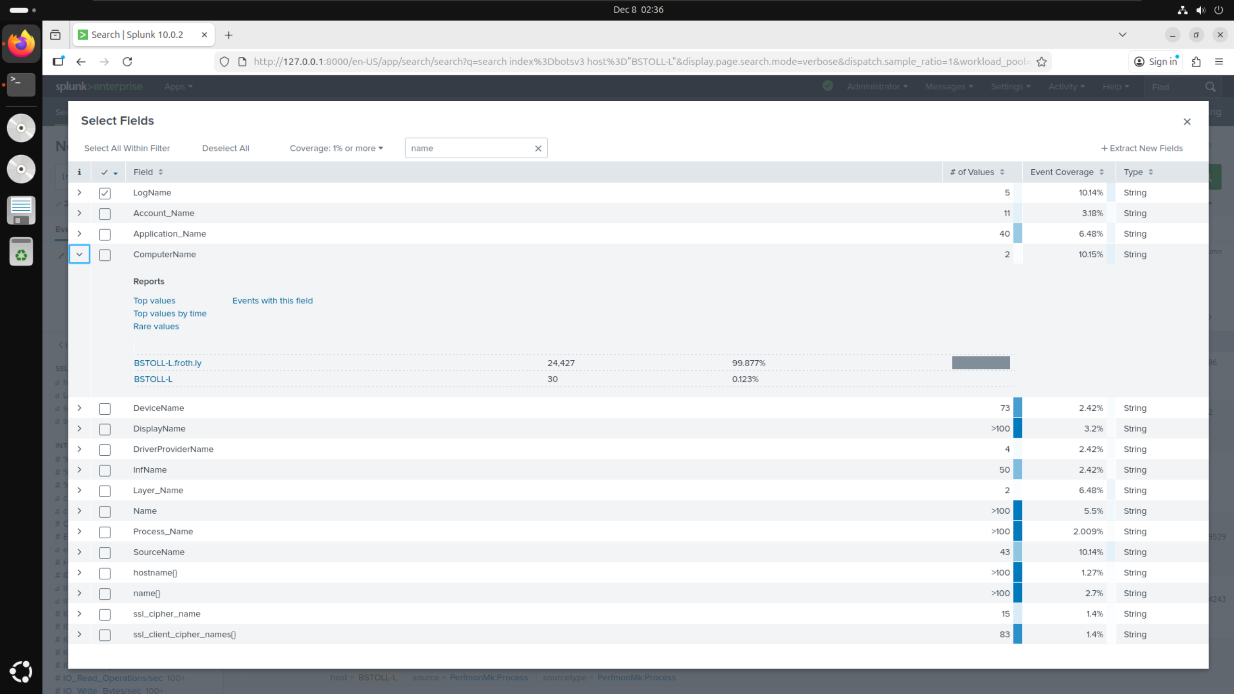

* Initially searched filters list for FQDN but could not find anything so instead searched for “name”
* Found filter called ComputerName which had the value of BSTOLL-L.froth.ly

# Conclusions:

# References: